Business Case: SQL Analysis of Pizza Sales
Project Overview: This project involves an in-depth analysis of pizza sales data using SQL. The primary objective is to derive meaningful insights that can aid in decision-making and strategy formulation.
Key Analyses Conducted:
- Revenue Breakdown:
  - Calculated the total revenue generated by each pizza type.
  - Analysed the percentage contribution of each pizza type to the overall revenue.
- Cumulative Revenue:
  - Tracked the cumulative revenue generated over time to understand sales trends and growth.
- Top-Performing Pizzas:
  - Identified the top 3 most ordered pizza types based on revenue within each pizza category.
SQL Techniques and Functions Used:
- Window functions for cumulative calculations.
- Join operations to combine multiple tables.
- Grouping and aggregation to summarize data.
- Subqueries for advanced data manipulation.
Insights:
- The analysis revealed the most popular and profitable pizza types, providing actionable insights for marketing and inventory management.
- Cumulative revenue tracking highlighted key sales periods and trends.

Basic Level:
1.Retrieve the total number of orders placed.
SELECT
DISTINCT COUNT(order_id) as total_orders
FROM mydatabase.orders;
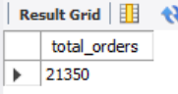

2.Calculate the total revenue generated from pizza sales.
SELECT
ROUND(SUM(od.quantity * p.price),0) as Total_Revenue
FROM order_details od
JOIN pizzas p ON od.pizza_id = p.pizza_id;
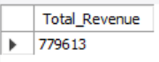

3.Identify the highest-priced pizza.
SELECT
pt.name,
p.price as max_pizza_price
FROM pizza_types pt
JOIN pizzas p ON pt.pizza_type_id = p.pizza_type_id
WHERE p.price = (SELECT MAX(price) FROM pizzas)


4.Identify the most common pizza size ordered.
SELECT p.size, count(od.order_details_id) as count
FROM order_details od
JOIN pizzas p ON od.pizza_id = p.pizza_id
GROUP BY 1
ORDER BY 2 DESC;
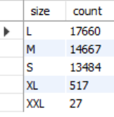

5.List the top 5 most ordered pizza types along with their quantities.
WITH RankedOrders AS (
SELECT pt.name,
SUM(od.quantity) AS Quantity,
ROW_NUMBER() OVER (ORDER BY SUM(od.quantity) DESC) AS OrdersRank
FROM pizza_types pt
JOIN pizzas p ON pt.pizza_type_id = p.pizza_type_id
JOIN order_details od ON p.pizza_id = od.pizza_id
GROUP BY pt.name
)
SELECT name, Quantity FROM RankedOrders
WHERE OrdersRank <= 5
ORDER BY Quantity DESC;

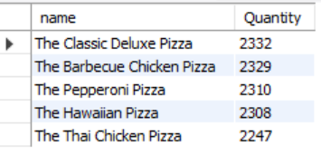

Intermediate Level :
6.Join the necessary tables to find the total quantity of each pizza category ordered.
SELECT pt.category, SUM(od.quantity) AS Quantity
FROM pizza_types pt
JOIN pizzas p ON pt.pizza_type_id = p.pizza_type_id
JOIN order_details od ON od.pizza_id = p.pizza_id
GROUP BY pt.category
ORDER BY pt.category DESC;
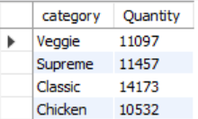

7.Determine the distribution of orders by hour of the day and arrange by orders.
SELECT HOUR(O.time) as HOUR, COUNT(order_id) AS Count_of_Orders
FROM orders O
GROUP BY 1
ORDER BY 2 DESC;
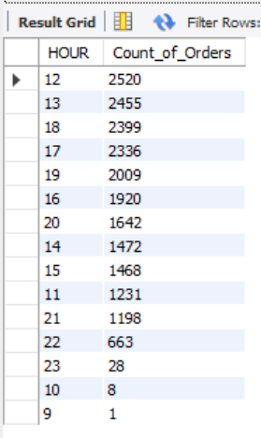
8.Join relevant tables to find the category-wise distribution of pizzas.
SELECT
PT.category,
PT.name,
COUNT(OD.order_details_id) as Count_of_Orders,
SUM(OD.quantity) as Quantity
FROM pizza_types PT
JOIN pizzas P
ON PT.pizza_type_id = P.pizza_type_id
JOIN order_details OD
ON P.pizza_id = OD.pizza_id
GROUP BY 1,2
ORDER BY 4 DESC;

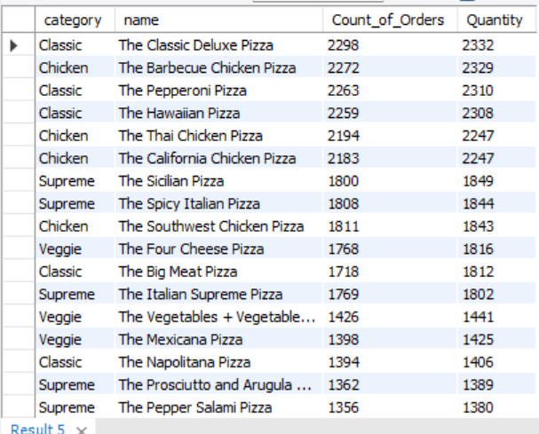

9.Group the orders by date and calculate the average number of pizzas ordered per day.
SELECT
ROUND(AVG(Count_of_Orders),0) as Avg_Orders_per_day,
ROUND(AVG(Quantity),0) as Avg_Pizzas_per_day
FROM (SELECT DATE(O.date) as Date, COUNT(O.order_id) as Count_of_Orders, SUM(OD.quantity) as Quantity
FROM orders O
JOIN order_details OD ON O.order_id = OD.order_id
GROUP BY 1) as Date_wise_Orders;
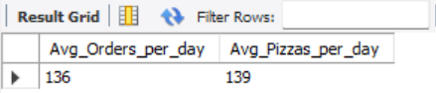

10.Determine the top 3 most ordered pizza types based on revenue.
SELECT PT.name, COUNT(OD.order_details_id) as Count_of_Orders, ROUND(SUM(OD.quantity * p.price),0) as Revenue_by_pizza_name
FROM pizza_types PT JOIN pizzas P ON PT.pizza_type_id = P.pizza_type_id
JOIN order_details OD ON P.pizza_id = OD.pizza_id
GROUP BY 1 ORDER BY 3 DESC;

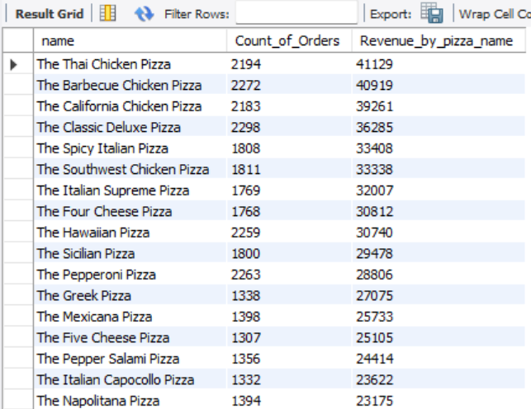
Advanced Level:
11.Calculate the percentage contribution of each pizza type to total revenue.
WITH RevenuePerCategory AS (
SELECT
PT.category,
ROUND(SUM(OD.quantity * P.price),0)AS Revenue
FROM pizza_types PT
JOIN pizzas P ON PT.pizza_type_id = P.pizza_type_id
JOIN order_details OD ON P.pizza_id = OD.pizza_id
GROUP BY PT.category
),
TotalRevenue AS (
SELECT
SUM(Revenue) AS TotalRevenue
FROM RevenuePerCategory
)
SELECT
RPC.category,
RPC.Revenue,
ROUND((RPC.Revenue / TR.TotalRevenue) * 100, 1) AS PercentageContribution
FROM RevenuePerCategory RPC
CROSS JOIN TotalRevenue TR
ORDER BY RPC.Revenue DESC;

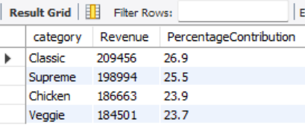

12.Analyse the cumulative revenue generated over time.
SELECT
O.date AS Date,
ROUND(SUM(P.price * OD.quantity), 0) AS Revenue,
ROUND(SUM(SUM(P.price * OD.quantity)) OVER (ORDER BY O.date), 0) AS CumulativeRevenue
FROM orders O
JOIN order_details OD ON O.order_id = OD.order_id
JOIN pizzas P ON OD.pizza_id = P.pizza_id
GROUP BY O.date
ORDER BY O.date;

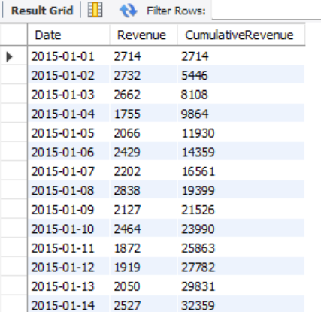

13.Determine the top 3 most ordered pizza types based on revenue for each pizza category.
WITH RevenuePerPizzaType AS (
SELECT
PT.category,
PT.name,
ROUND(SUM(OD.quantity * P.price),0)AS Revenue
FROM pizza_types PT
JOIN pizzas P ON PT.pizza_type_id = P.pizza_type_id
JOIN order_details OD ON P.pizza_id = OD.pizza_id
GROUP BY PT.category, PT.name
)
SELECT * FROM (
SELECT
RPPT.category,
RPPT.name,
RPPT.Revenue,
RANK() OVER(PARTITION BY category ORDER BY Revenue DESC) as Rank_by_Category
FROM RevenuePerPizzaType RPPT
ORDER BY RPPT.category, RPPT.Revenue DESC) as ABC
WHERE Rank_by_Category <= 3;

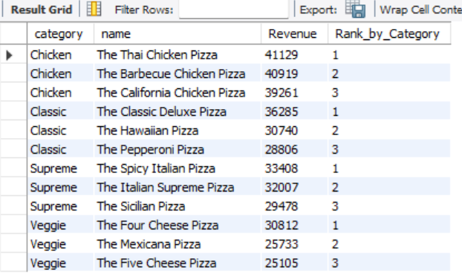
14.Determine the Revenue for each month and cumulative revenue over each month.
SELECT
EXTRACT(YEAR_MONTH FROM O.date) AS Month,
ROUND(SUM(P.price * OD.quantity), 0) AS Revenue,
ROUND(SUM(SUM(P.price * OD.quantity)) OVER (ORDER BY EXTRACT(YEAR_MONTH FROM O.date)), 0) AS CumulativeRevenue
FROM orders O
JOIN order_details OD ON O.order_id = OD.order_id
JOIN pizzas P ON OD.pizza_id = P.pizza_id
GROUP BY EXTRACT(YEAR_MONTH FROM O.date)
ORDER BY EXTRACT(YEAR_MONTH FROM O.date);

